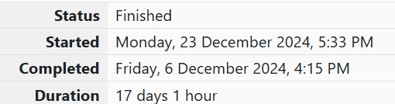

WEEK 5

1.OBJECTIVE

Write a program that prints a simple chessboard.

CODE

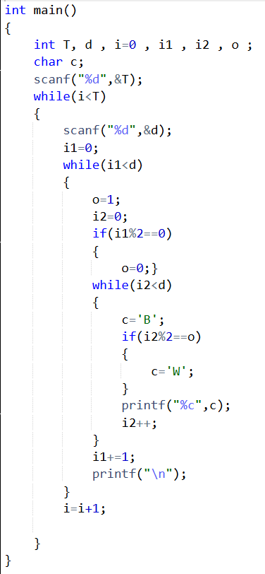

OUTPUT

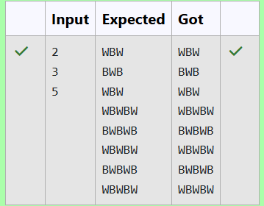

2.OBJECTIVE

Let’s print a chessboard! Write a program that takes input: The first line contains T, the number of test cases Each test case contains an integer N and also the starting character of the chessboard

CODE

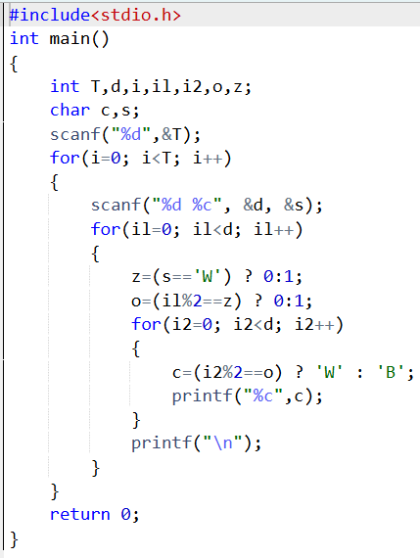

OUTPUT

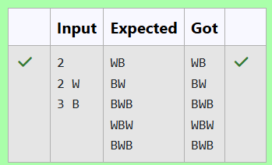

3.OBJECTIVE

Decode the logic and print the Pattern that corresponds to given input. If N= 3 then pattern will be : 10203010011012 \*\*4050809 \*\*\*\*607 If N= 4, then pattern will be: 1020304017018019020 \*\*50607014015016 \*\*\*\*809012013 \*\*\*\*\*\*10011

CODE

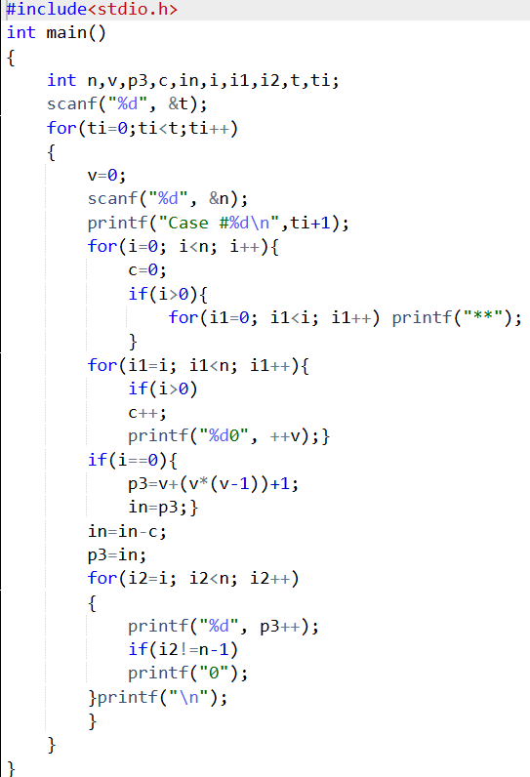

OUTPUT

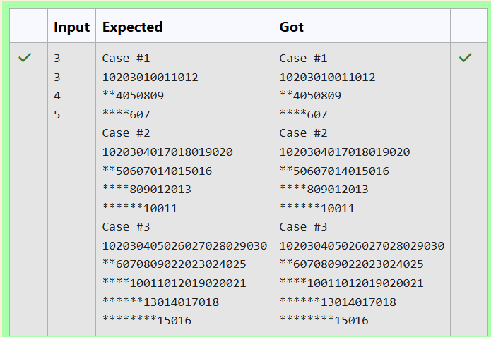

4.OBJECTIVE

The k-digit number N is an Armstrong number if and only if the k-th power of each digit sums to N. Given a positive integer N, return true if and only if it is an Armstrong number.

CODE

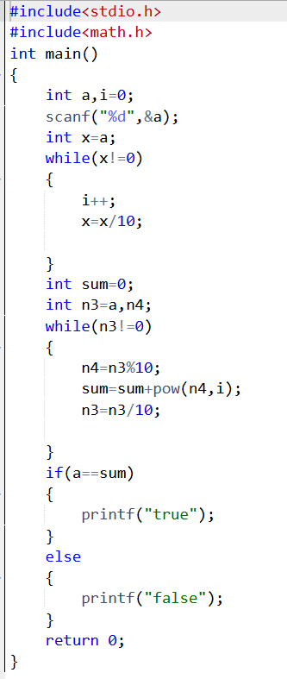

OUTPUT

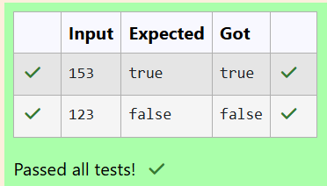

5.OBJECTIVE

Take a number, reverse it and add it to the original number until the obtained number is a palindrome. Constraints 1<=num<=99999999 Sample Input 1 32 Sample Output 1 55 Sample Input 2 789 Sample Output 2 66066

CODE

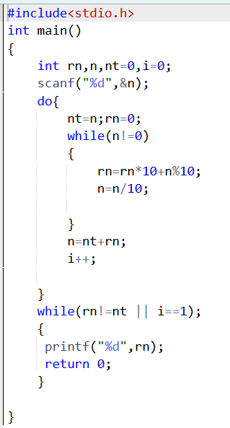

OUTPUT

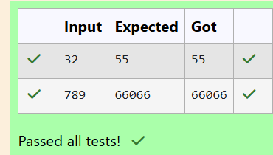

6.OBJECTIVE

A number is considered lucky if it contains either 3 or 4 or 3 and 4 both in it. Write a program to print the nth lucky

number. Example, 1st lucky number is 3, and 2nd lucky number is 4 and 3rd lucky number is 33 and 4th lucky number

is 34 and so on. Note that 13, 40 etc., are not lucky as they have other numbers in it.

The program should accept a number 'n' as input and display the nth lucky number as output.

CODE

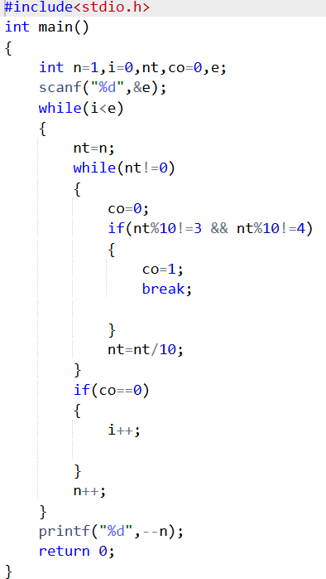

OUTPUT

